Last Stand

Open Space for Eatontown Borough

**Version**: 0.6a

**Date**: 21 October 2019

**Contact**: Stephen Fratini, [sfratini@hotmail.com](mailto:sfratini@hotmail.com)

**History**

* v0.1 – v0.3: preliminary draft
* v0.4: presented to EEC on July 18, 2019
* v0.5: presented to mayor, business administrator, and planning/zoning on July 26, 2019
* v0.6: updates based on meeting of July 26, 2019
* v0.6a: added watermark “DRAFT – not yet approved” (21 October 2019)

Table of Contents

1 Purpose 2

2 Goals 2

2.1 Increase Resident Proximity to Parks 2

2.2 Shield Residents from Intrusive Development 2

2.3 Enhance Property Value 2

2.4 Support Pedestrian / Bike Connectivity around the Borough 3

3 Current Situation 3

3.1 Park Connectivity 3

3.2 Reactive Approach to Site Proposals 3

3.3 Loss of Open Space to Urbanization 4

4 Proposal 6

4.1 Identify Available Open Space 6

4.2 Select Open Space Targets 6

4.3 Identify and Secure Funding for Purchases 7

5 Issues to be Addressed 7

5.1 Funding 7

5.2 Timing of Purchases 8

5.3 Administration of Additional Parks 8

6 Next Steps 8

7 Items to Investigate 8

# Purpose

The purpose of the proposal is to define a proactive open space plan for Eatontown in which the borough actively identifies and plans to purchase open space property with the goal of increasing open space for use by residents of the town.

# Goals

## Increase Resident Proximity to Parks

A goal of this proposal is to decrease the walking distance for each resident to a borough park.

This goal is inspired by the “10-minute walk” initiative. From the associated website (<https://10minutewalk.org/>):

“Make the 100% Promise to make sure that everyone in your city has safe, easy access to a quality park within a 10-minute walk of home by 2050.”

Through the 10-Minute Walk Campaign (NRPA with support from The JPB Foundation) offers grants and technical assistance to support planning efforts that help cities increase access to high-quality parks within a 10-minute walk. In the third round of grants, 10 cities will receive $40,000 to work alongside NRPA, The Trust for Public Land (TPL), and the Urban Land Institute (ULI) to develop their highest, best, and measurable commitment to the 10-Minute Walk Campaign. For further information, see <https://www.nrpa.org/our-work/partnerships/initiatives/10-minute-walk/grants-technical-assistance/>.

## Shield Residents from Intrusive Development

As the borough runs out of open space (including both privately owned and borough-owned), businesses and the associated development of buildings is getting very close to residential areas. A goal of this proposal is to identify open spaces that can be used for additional parks in the borough. This would include the possible purchase of privately owned lots by the borough via funding from county, state, and federal sources as well as private charities. This approach adds parks (albeit most likely smaller than the current set of parks) but also has the effect of lessening additional business development in close proximity to residential areas.

Pocket parks intermixed among businesses is another possibility in some area of Eatontown.

## Enhance Property Value

An increase in the number of borough parks and shield of residential areas from business development should lead to higher properties. This can be seen more easily by comparing to the opposite, i.e., fewer parks and businesses in the backyard of more and more residents (which is happening as businesses are buying the few remaining lots which are in some cases right next to residential areas).

There are studies that back-up the above claim. See, for example,

* Green and Open Space Increase Neighboring Property Values, <https://carolinaangles.com/2018/04/17/green-and-open-space-increase-neighboring-property-values/>
* Literature Survey: Green Space and Property Values by Natasha Catrakilis, <https://sites.duke.edu/urbaneconomics/?p=1441>
* Impact of Open Space Preservation on Property Values, <https://www.cga.ct.gov/2006/rpt/2006-R-0344.htm>
* Parks/Open Space and Residential Property Value: A Literature Survey To Ascertain Their Mutual Relationship, <https://www.researchgate.net/publication/318885690_PARKSOPEN_SPACE_AND_RESIDENTIAL_PROPERTY_VALUE_A_LITERATURE_SURVEY_TO_ASCERTAIN_THEIR_MUTUAL_RELATIONSHIP>
* Outlook: How Can Open Space Add Value to Real Estate Development? <https://urbanland.uli.org/news/open-space-development-outlook/>
* Trail Effects on Neighborhoods: Home Value, Safety, Quality of Life, <https://www.americantrails.org/resources/trail-effects-on-neighborhoods-home-value-safety-quality-of-life>
* The Effects of Open Space on Residential Property Values, <https://www.jstor.org/stable/3146847?seq=1#page_scan_tab_contents>
* Open Space, Residential Property Values, and Spatial Context, <https://www.researchgate.net/publication/222666218_Open_Space_Residential_Property_Values_and_Spatial_Context>
* The Effect of Open Space on Residential Property Values in St. Paul, MN, <https://msu.edu/~sta/Anderson_openspace_thesis.pdf>
* The Effect Of Open Space On Residential Property Values In Wake County, NC, <https://cdr.lib.unc.edu/concern/masters_papers/2n49t365m>

## Support Pedestrian / Bike Connectivity around the Borough

Other than for shorter distances, bike and pedestrian connectivity in the borough is difficult because of major street crossings (Rt. 36, Rt. 35, Rt. 547 / Wyckoff, Broad St. and several other high-traffic roads such as Industrial Way). A goal of the borough (supported by the Complete Streets Advisory Committee) is to connect the various parts of town via various safe bicycle routes and enhanced pedestrian crossings. Additional parks can also assist with this goal.

# Current Situation

## Park Connectivity

Eatontown is currently in the process of enhancing safe connectivity among our parks. The addition of parks will facilitate the connectivity among the existing parks.

## Reactive Approach to Site Proposals

Eatontown site approval processes are typically reactive to site proposals that infringe on residential area. This situation is not unique to Eatontown. Planning and zoning are bound by law to be impartial and to follow borough ordinances, businesses have experts representing their cases (e.g., engineers and lawyers) and the residents are typically inexperienced public speakers and do not have expertise in defending their position in such matters. This means that the residents lose the argument in many cases and has led to major and disruptive business construction very close to residential areas.

The approach suggested here is to identify properties (typically open lots owned by private interests or government) where development would infringe on residential areas and that could be better used as borough parks. Given that the borough has limited funds (if any) to purchase such properties, it would be necessary to apply for grants from government or charities.

## Loss of Open Space to Urbanization

Eatontown has lost a considerable amount of open space to urbanization over the last several decades. The first figure below shows that Eatontown has lost over 600 acres of open space (a combination of forest, wetlands and barren areas) to urbanization between 1986 and 2012. The loss continues to the present (e.g., the 10-acre lot on the East-side of Marin way was recently deforested for a business). The second figure shows an increase in impervious surface from 500 acres in 1986 to 1280 acres in 2012 (again, this trend has continued). [Both of the figures are from <https://www.njmap2.com/landuse/>. First, search on Eatontown and then click on the Urbanization button on the left.]

Time is running out before there is no open space left in Eatontown. Now is the last chance to secure some select areas to be preserved as open space (with associated parks in some cases).

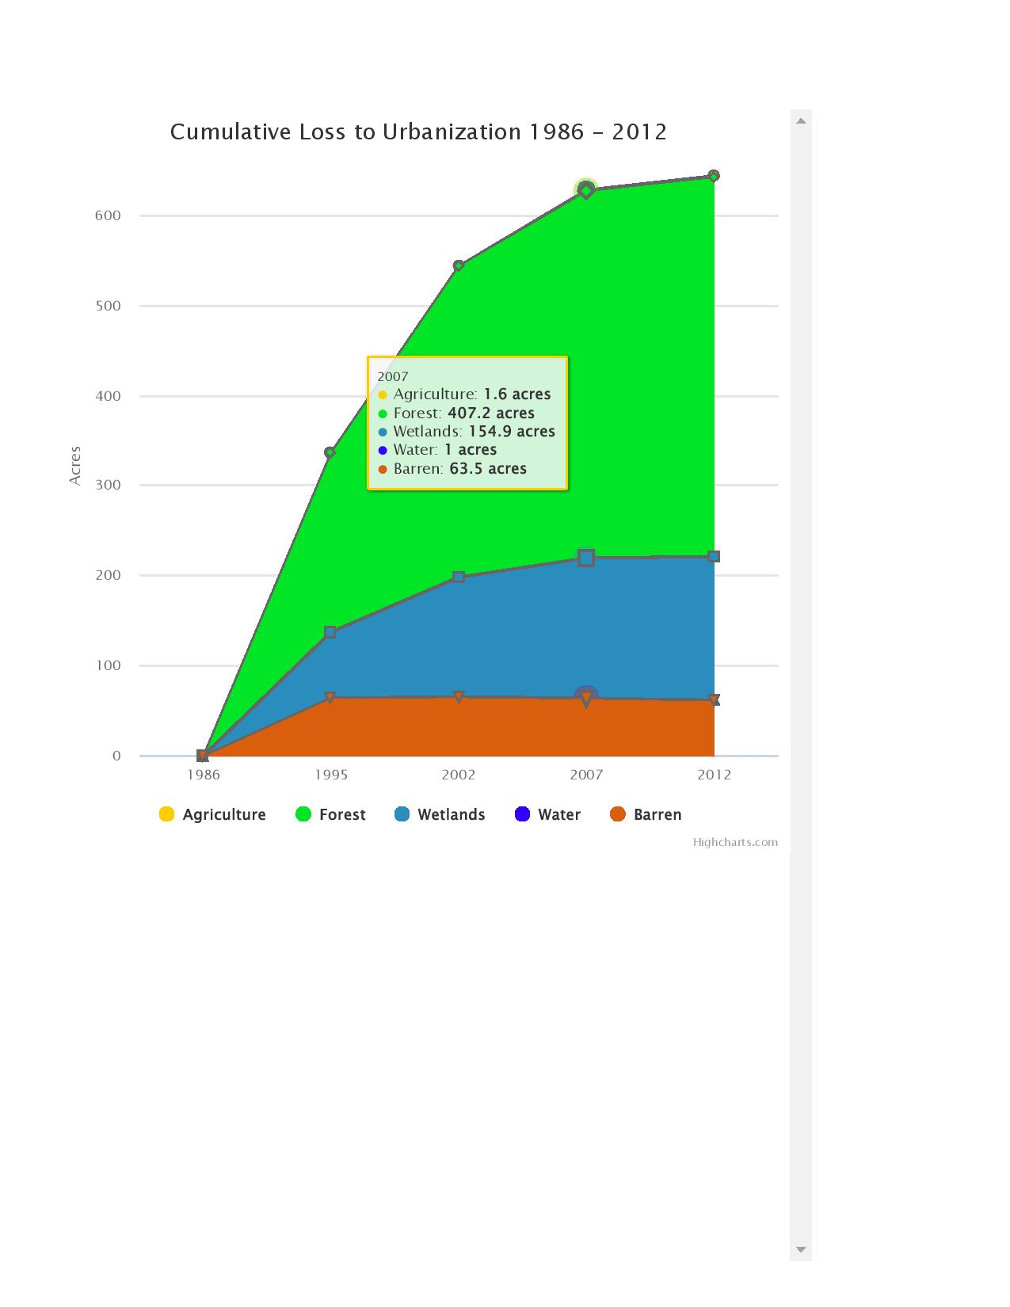

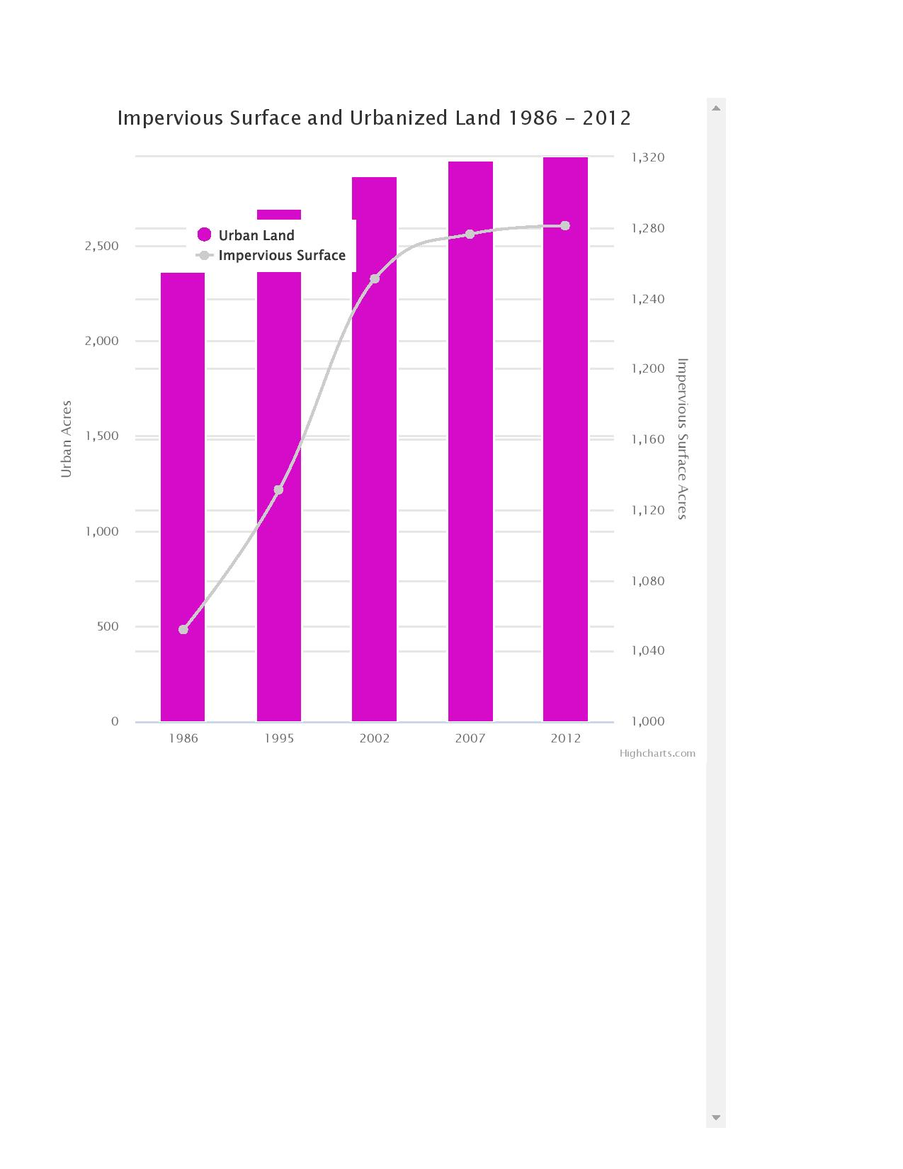

# Proposal

## Identify Available Open Space

The first step is to identify open spaces. This includes existing property owned by Eatontown borough, other government-owned property (e.g., county or state) and privately owned areas that possibly be purchased by the borough using grant money from government or private sources (e.g., charities).

## Select Open Space Targets

Once the open spaces are identified, the next task is to determine which of the spaces are of the highest priority for use and purchase (in the case of privately owned parcels). The priority should be based on the goals stated in Section 2 and the probability of being able to secure the property (e.g., ability to secure funding and the owner's willingness to sell the property to the borough).

## Identify and Secure Funding for Purchases

The first step is to determine the various government agencies and charities that could possibly help in funding the purchase of open space. The second step is to actually write the grant proposals which clearly can be a time-consuming activity. Hiring (by the borough) of a grant writer (even part-time) would help expedite the process.

# Issues to be Addressed

## Funding

Partial list of potential funding sources:

* Monmouth Conservation Foundation, <http://www.monmouthconservation.org/>
* The Trust for Public Land Use, <https://www.tpl.org/>
* (as noted earlier in this document) 10-Minute Walk Planning Grant and Technical Assistance, <https://www.nrpa.org/our-work/partnerships/initiatives/10-minute-walk/grants-technical-assistance/>
* Whale Pond Brook Watershed Association, <https://restorethewatershed.net/>
* Open Space Institute, <https://www.openspaceinstitute.org/apply-for-a-grant>
* Municipal Open Space Grant Program, <https://www.monmouthcountyparks.com/page.aspx?ID=2588>
  + The Monmouth County Municipal Open Space Grant Program is a competitive program. The project eligibility and evaluation criteria are described in the Policy and Procedures Manual.
  + Applications for 2019 funding will be mailed to Mayors, Administrators and Clerks of all Monmouth County municipalities in June 2019.
* State of New Jersey, Department of Environment Protection (DEP), Green Acres Program, <https://www.nj.gov/dep/greenacres/>
  + Green Acres Mission: To achieve, in partnership with others, a system of interconnected open spaces, whose protection will preserve and enhance New Jersey's natural environment and its historic, scenic, and recreational resources for public use and enjoyment. The Green Acres Program was created in 1961 to meet New Jersey's growing recreation and conservation needs. Together with public and private partners, Green Acres has protected over half a million acres of open space and provided hundreds of outdoor recreational facilities in communities around the State.
* Sale of various low utility lots (owned by Eatontown) and using the money to fund higher priority lots for open space uses such as parks
* Donations from landowners
  + This would likely require some sort of remuneration (not necessarily monetary) from the borough to the landowner.
* Need to find a link to the federal DEP site for open space (if such exists)

## Timing of Purchases

Given that some of the possible targets for purchase are privately owned and currently up for sale, there is a significant timing issue. The property owners cannot be expected to hold off on the sale of their property while Eatontown is in search of grants. Conversely, the funding organization need to have a clear picture of what Eatontown would like to purchase and have some assurance the property will be available for purchase when the grant money is awarded.

## Administration of Additional Parks

If we are successful, there will be additional parks to manage by (presumably) the Eatontown Department of Public Works (DPW). This may entail the hiring of additional staff or at least additional help on a contract basis.

# Next Steps

* Introduce to the EEC (At the 18 July 2019 meeting of the EEC, Steve Fratini introduced the proposal. The EEC approve the document for implementation.)
* Get buy-in from Eatontown government (mayor and city council) and administration (On 26 July 2019, Steve Fratini and Sara Breslow attended a meeting with Eatontown mayor, business administrator and planning and zoning officier. It was concluded that the EEC should continue working on the implementation of the plan.)
* Determine potential set of open space purchases
  + Get list of government owned open space sites (at the borough, county, state and federal levels)
  + Get list of privately owned open space sites
  + Regarding open space, a mapping of species and habitat (animal and plant) would be helpful in protecting areas of ecological significance (such information is missing from the current (2012) Eatontown Environment Resource Inventory (ERI).
* Prioritize list of open space sites
* Inform landowners of intent
* Secure funding for purchase

# Items to Investigate

* Determine if Eatontown has a Build out Analysis.
* The Eatontown contracted engineering firm (T&M) helped Red Bank regarding open space grants. Need to look into this further.
* Borough council is considering a strategic plan, which could include future build-out as part of the analysis.